Practical 3

Part A:
Aim:
1. Distinct points (Point.java + Driver.java with main)
(a) Create class Point with private int x, y and constructor. (b) Override toString() to return “(x, y)”.
- Override equals(Object) to be true when both x and y match, and hashCode() to agree (e.g. Objects.hash(x, y)).
- In Driver.main: build a Point[] with some repeated coordinates. (e) Count distinct points: for each point, use equals() to check whether it already appeared earlie r; count those that did not.
(f) Print “Distinct: N”.
Expected output: 5 points with 2 repeats → “Distinct: 3”.

Point.java:
Code:
import java.util.Objects;

public class Point {

private int x;
private int y;

// Constructor
public Point(int x, int y) {
this.x = x;
this.y = y;
}

// toString()
@Override
public String toString() {
return "(" + x + ", " + y + ")";
}

// equals()
@Override
public boolean equals(Object obj) {

if (this == obj)
return true;

if (obj == null || getClass() != obj.getClass())
return false;

Point p = (Point) obj;

return x == p.x && y == p.y;
}

// hashCode()
@Override
public int hashCode() {
return Objects.hash(x, y);
}
}

Driver.java:
Code:
public class Driver {

public static void main(String[] args) {

Point[] points = {
new Point(2, 3),
new Point(4, 5),
new Point(2, 3),
new Point(6, 7),
new Point(4, 5)
};

int distinct = 0;

for (int i = 0; i < points.length; i++) {

boolean alreadyPresent = false;

for (int j = 0; j < i; j++) {

if (points[i].equals(points[j])) {
alreadyPresent = true;
break;
}
}

if (!alreadyPresent) {
distinct++;
}
}

System.out.println("Points:");

for (Point p : points) {
System.out.println(p);
}

System.out.println("\nDistinct: " + distinct);
}
}

Output:
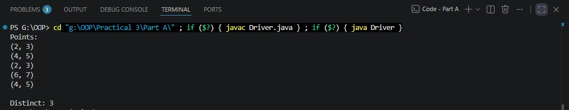

Aim:
2. Duplicate card check (Card.java + Driver.java)
(a) Create class Card with private String rank, suit and a constructor. (b) Override toString() to return rank + “ of ” + suit (e.g. “Queen of Hearts”). (c) Override equals()/hashCode() by rank + suit.
(d) In Driver.main: add cards to a Card[] one at a time; before adding each, use equals() to check it against the earlier cards. (e) Print “Duplicate found: <card>” the first time a repeat appears.
Expected output: a second “Ace of Spades” → “Duplicate found: Ace of Spades”.

Card.java
Code:
import java.util.Objects;

public class Card {

private String rank;
private String suit;

// Constructor
public Card(String rank, String suit) {
this.rank = rank;
this.suit = suit;
}

// toString()
@Override
public String toString() {
return rank + " of " + suit;
}

// equals()
@Override
public boolean equals(Object obj) {

if (this == obj)
return true;

if (obj == null || getClass() != obj.getClass())
return false;

Card other = (Card) obj;

return rank.equals(other.rank) && suit.equals(other.suit);
}

// hashCode()
@Override
public int hashCode() {
return Objects.hash(rank, suit);
}
}

Driver.java Code:
public class Driver1{

public static void main(String[] args) {

Card[] cards = new Card[6];

cards[0] = new Card("Ace", "Spades");
cards[1] = new Card("King", "Hearts");
cards[2] = new Card("Queen", "Diamonds");
cards[3] = new Card("Jack", "Clubs");
cards[4] = new Card("Ace", "Spades"); // Duplicate
cards[5] = new Card("Ten", "Hearts");

boolean duplicateFound = false;

for (int i = 0; i < cards.length; i++) {

for (int j = 0; j < i; j++) {

if (cards[i].equals(cards[j])) {

System.out.println("Duplicate found: " + cards[i]);
duplicateFound = true;
break;
}
}

if (duplicateFound) {
break;
}
}
}
}

Output:

3. (For Advanced Learners – home) Fractions (Fraction.java + Driver.java)
(a) Create class Fraction with private int num, den.
(b) In the constructor, reduce to lowest terms: compute g = gcd(num, den) and divide both by g.
(c) Override toString() to return num + “/” + den.
(d) Override equals()/hashCode() using the reduced num and den.
(e) In Driver.main: create several equivalent fractions (1/2, 2/4, 3/6) and confirm they are all equal and print the same.
Expected output: new Fraction(2,4) prints “1/2” and equals new Fraction(1,2).

Code:
Fraction.java
import java.util.Objects;

public class Fraction {

private int num;
private int den;

// Constructor
public Fraction(int num, int den) {

if (den == 0) {
throw new IllegalArgumentException("Denominator cannot be zero.");
}

// Keep denominator positive
if (den < 0) {
num = -num;
den = -den;
}

// Reduce fraction
int g = gcd(Math.abs(num), den);

this.num = num / g;
this.den = den / g;
}

// Calculate GCD using Euclidean algorithm
private static int gcd(int a, int b) {

while (b != 0) {
int temp = a % b;
a = b;
b = temp;
}

return a;
}

// Convert fraction to string
@Override
public String toString() {
return num + "/" + den;
}

// Compare reduced numerator and denominator
@Override
public boolean equals(Object obj) {

if (this == obj) {
return true;
}

if (obj == null || getClass() != obj.getClass()) {
return false;
}

Fraction other = (Fraction) obj;

return num == other.num && den == other.den;
}

// Generate hash code using reduced values
@Override
public int hashCode() {
return Objects.hash(num, den);
}
}

Driver.java
public class Driver2 {

public static void main(String[] args) {

Fraction f1 = new Fraction(1, 2);
Fraction f2 = new Fraction(2, 4);
Fraction f3 = new Fraction(3, 6);
Fraction f4 = new Fraction(4, 8);

System.out.println("f1 = " + f1);
System.out.println("f2 = " + f2);
System.out.println("f3 = " + f3);
System.out.println("f4 = " + f4);

System.out.println();

System.out.println("f1 equals f2: " + f1.equals(f2));
System.out.println("f1 equals f3: " + f1.equals(f3));
System.out.println("f1 equals f4: " + f1.equals(f4));

System.out.println();

System.out.println("All fractions are equal: "
+ (f1.equals(f2) && f2.equals(f3) && f3.equals(f4)));
}
}

Output
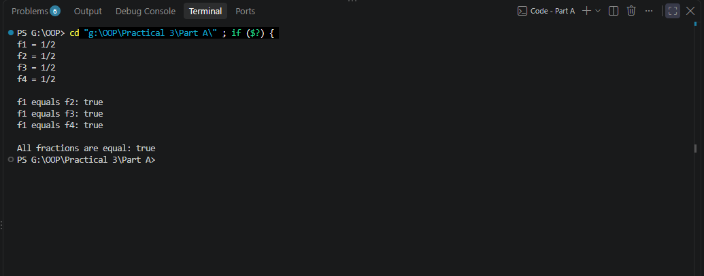

Key Questions / Analysis / Interpretation to be evaluated during/after Implementation

- Why must equals() and hashCode() be overridden together?

Ans.
equals() determines whether two objects are logically equal, while hashCode() produces a hash value used by collections such as HashSet and HashMap.
Java's contract says:
If two objects are equal according to equals(), they must have the same hashCode().
For example, in your Account class:
@Override
public boolean equals(Object o) {
Account other = (Account) o;
return accountNumber.equals(other.accountNumber);
}

@Override
public int hashCode() {
return Objects.hash(accountNumber);
}
If two accounts have the same account number:
Account A → AC0001
Account B → AC0001
then:
A.equals(B) → true
A.hashCode() → same value
B.hashCode() → same value
If you override only equals() but not hashCode(), hash-based collections may treat logically equal objects as different.

- What does the default Object.toString() return, and why override it?

Ans.
Every Java class ultimately inherits toString() from the Object class if it doesn't provide its own version.
The default result is generally in this form:
ClassName@hexadecimalHashCode
For example:
Account account = new Account("Rahul", 5000);

System.out.println(account);
Without overriding toString(), you might get something like:
Account@5acf9800
This isn't useful to a user because it doesn't show the account's meaningful information.
So we override it:
@Override
public String toString() {
return "Account Number : " + accountNumber
+ ", Owner : " + ownerName
+ ", Balance : Rs." + balance;
}
Now:
System.out.println(account);
produces something meaningful:
Account Number : AC0001, Owner : Rahul, Balance : Rs.5000

- What is the difference between a static nested class and an inner class?

Ans.

Static Nested Class | Inner Class
Declared with static | No static
Does not require outer object | Requires outer object
Not associated with a particular outer instance | Associated with an outer instance
Cannot directly access outer instance fields | Can directly access outer instance fields
Example: Customer.Address | Example: customer.new Address()

